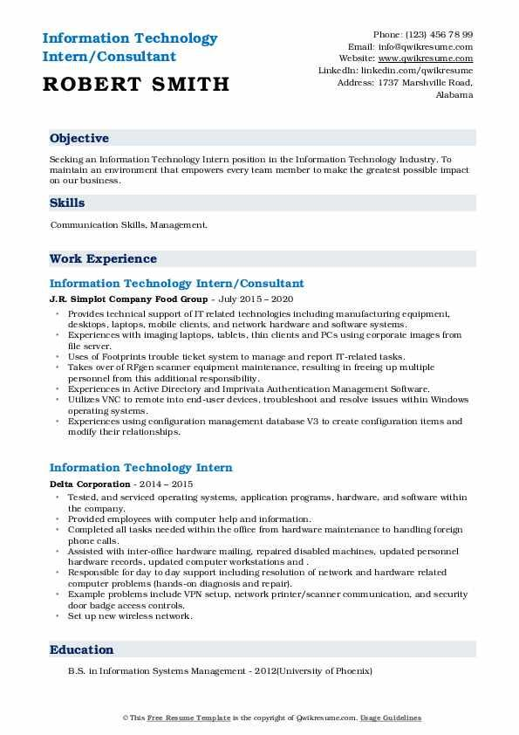
Information Technology Intern/Consultant
ROBERT SMITH
Phone: (123) 456 78 99 Email: info@qwikresume.com Website: www.qwikresume.com Linkedin: linkedin.com/qwikresume Address: 1737 Marshville Road,
Alabama
Objective
Secking an Information Technology Intern position in the Information Technology Industry. To maintain an environment that empowers every team member to make the greatest possible impact on our business.
Skills
Communication Skills, Management.
Work Experience
Information Technology Intern/Consultant
J.R. Simplot Company Food Group - July 2015-2020
• Provides technical support of IT related technologies including manufacturing equipment, desktops, laptops, mobile clients, and network hardware and software systems.
Experiences with imaging laptops, tablets, thin clients and PCs using corporate images from file server.
⚫Uses of Footprints trouble ticket system to manage and report IT-related tasks.
Takes over of RFgen scanner equipment maintenance, resulting in freeing up multiple personnel from this additional responsibility.
⚫ Experiences in Active Directory and Imprivata Authentication Management Software,
Utilizes VNC to remote into end-user devices, troubleshoot and resolve issues within Windows operating systems.
•Experiences using configuration management database V3 to create configuration items and modify their relationships.
Information Technology Intern
Delta Corporation - 2014-2015
• Tested, and serviced operating systems, application programs, hardware, and software within the company.
• Provided employees with computer help and information.
"
Completed all tasks needed within the office from hardware maintenance to handling foreign phone calls.
⚫ Assisted with inter-office hardware mailing, repaired disabled machines, updated personnel hardware records, updated computer workstations and.
Responsible for day to day support including resolution of network and hardware related computer problems (hands-on diagnosis and repair).
Example problems include VPN setup, network printer/scanner communication, and security door badge access controls.
• Set up new wireless network.
Education
B.S. in Information Systems Management - 2012/University of Phoenix)
©This Free Resume Template is the copyright of wiresume.com. Usage Guidelines

